Dear Parents,

Following the announcement from the government yesterday, I am writing to confirm that school will reopen to children from eligible year groups on TUESDAY 2 JUNE. School will take Monday 1 June as an INSET day to finalise our preparations and ensure the school is safe for children and staff to return.

As previously mentioned, life at school will be quite different to what the children experienced pre-lockdown. Staff will do everything they can to make the children feel safe and happy but your help in managing their expectations will be invaluable. Please do find some time this weekend to prepare your child for the necessary restrictions we will have in place. In particular, the children need to understand that they cannot play with all their friends or may not be in their usual classroom with their usual teacher.

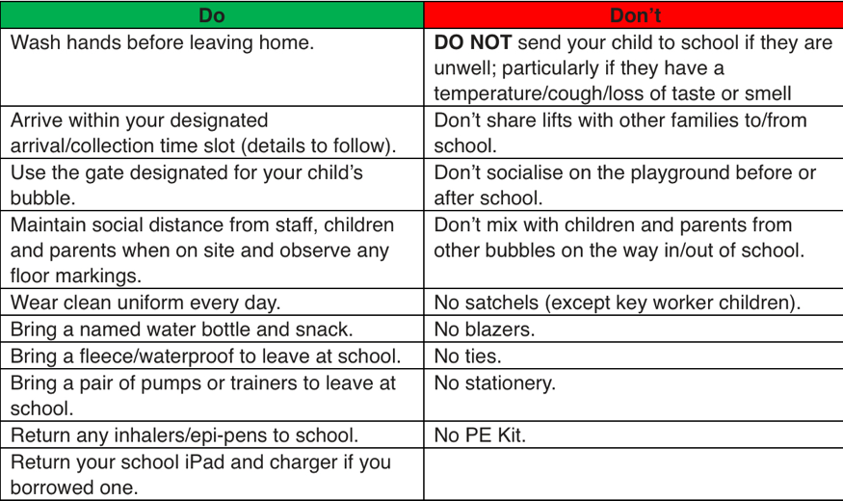
Our Guidance for Reopening document was very thorough but I thought it would be useful to highlight some key practical information in readiness for next week. Please see the dos and don’ts below:

For the first few days, we are going to extend our arrival and collection time windows for the safety of everyone accessing the school site. Details of these times will follow later today. Once we see how this works in practice, we will review the timings to ensure a steady and safe flow of footfall through the entry points. Maintaining social distance during these transitions will be extremely important. We thank you for your patience whilst we work this through.

As we progress through the next few weeks, it is highly likely that our arrangements may need to be adapted to reflect updates to the government guidance. We will communicate any changes to parents as quickly as we can.

We are very much looking forward to welcoming you back to Froebelian next week.

Best wishes,
Mrs Catherine Dodds

Catherine Dodds | Headteacher
Apple Teacher
0113 258 3047 | 07710 024331
The Froebelian School, Horsforth, Leeds LS18 4LB
Giving a flying start to the citizens of tomorrow

